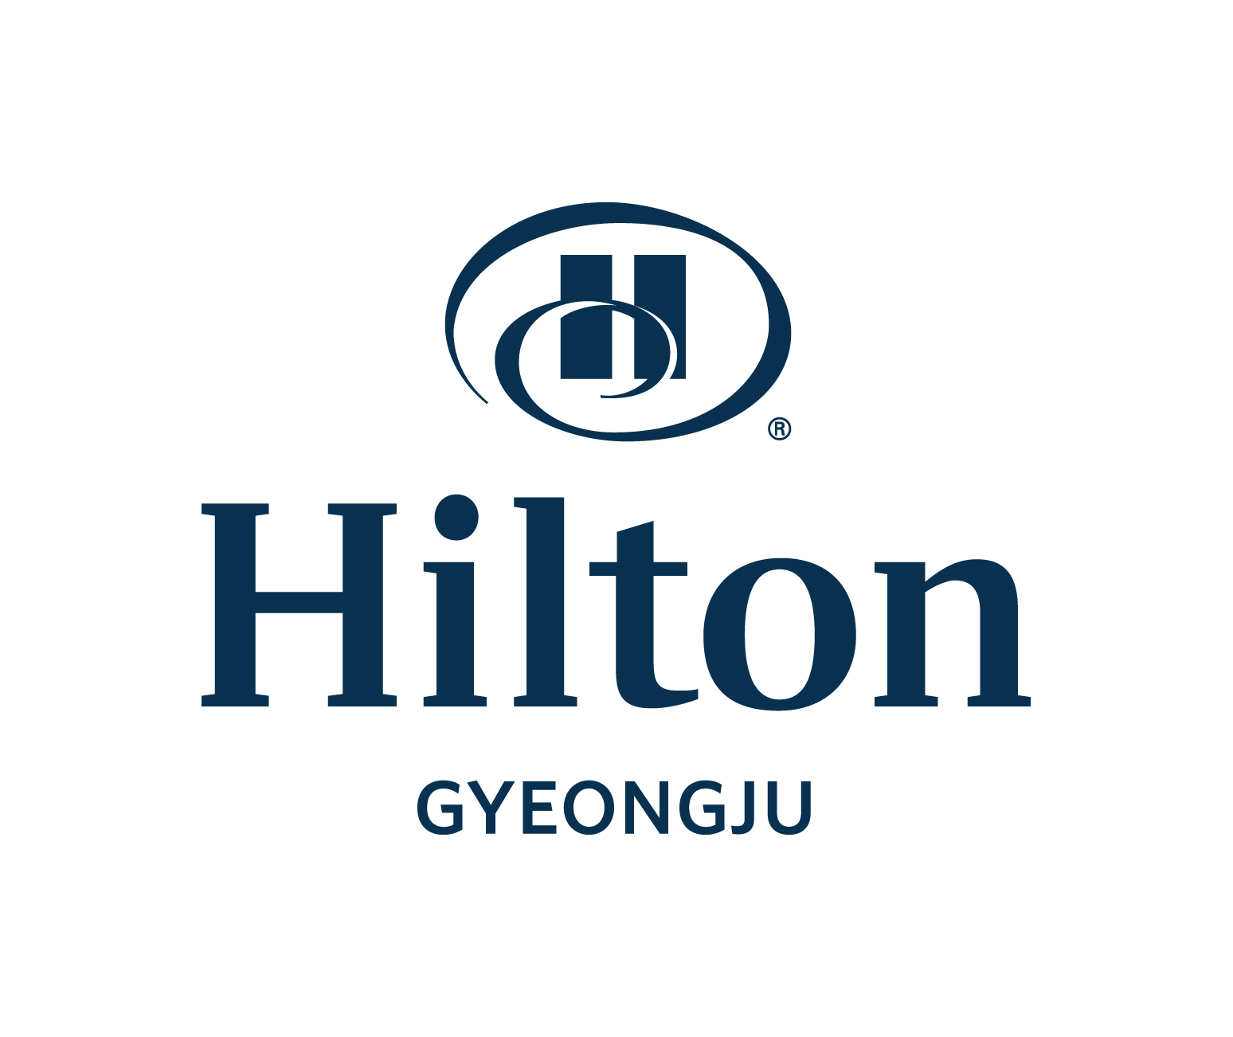
Hotel Reservation Form
COLING 2022(Oct 10~18. 2022)

August 25 ~ 27, 2009
*Please complete this form with all requested information and send it to the hotel directly by e-mail or fax.
E-mail: donghyo.seo@hilton.com/Reservation Manager Fax: +82-54-745-7799, Phone: +82-54-740-1232~4
*Please check-out reservation number after sending room reservation form.

Participant Information
First Name: Last Name: Title: □Mr. □Ms.
Company Name : Position:
Sharing Room with First Name(Optional): Last Name:
Phone: Fax: E-mail:
Arrival Date : Departure Date: No. of Nights:
Special request and comments :
Non smoking : All Rooms (Not available Smoking room)

Accommodation Information
Room Type | Rate | Remark
Deluxe Single room (Sun~Thu) | □ KRW 230,000 | 1pax Breakfast included  on the room rate
Deluxe Single room (Friday) | □ KRW 260,000 | 1pax Breakfast included  on the room rate
Deluxe Single room (Saturday) | □ KRW 330,000 | 1pax Breakfast included  on the room rate
Additional Breakfast Buffet | □ KRW 40,000 Per Person | Lakeside (06:30~ 10:00)
* 10% tax is included in the above rate.
* Free Wireless Internet for 24 hours
* Check-in time: 15:00 PM, Check-out time: 11:00 AM

Payment Information
In order to guarantee your reservation, your credit card information must be accompanied.
□ AMEX □ VISA □ Master □ Dinners □ JCB □ Other( )
Card No.: Expiration Date(mm/yy)
Cardholder’s Name: Date: Signature:

Cancellation Policy
- If you wish to cancel, please do so 5days prior to arrival to avoid cancellation penalties

♦ Confirmation
예약번호 |  | 담당자 | Myung-Soo. Jeon: 010 2688 5986

